Introduction to Computer Programming

# Name: Hassan Shahzad

# Class: BSCS 7C

# CMS ID: 211798

# Lab 07:

## Task 01:

#include <stdio.h>

#include <ctype.h>

int main()

{

// asking to enter a letter

printf("Enter a letter: ");

char x;

scanf_s("%c", &x);

// checking whether the input is a letter

if (isalpha(x)){

// checking whether the entered letter is vowel

switch (x){

case 'a':

case 'e':

case 'i':

case 'o':

case 'u':

case 'A':

case 'E':

case 'I':

case 'O':

case 'U':

printf("The entered letter %c is a vowel.\n", x);

break;

// if not vowel then print the following string.

default:

printf("The entered letter %c is a consonant.\n", x);

}

}

else

printf("The entered is not a letter.\n");

return 0;

Output:

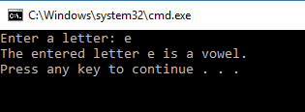

## Task 02:

#include <stdio.h>

#include <ctype.h>

int main()

{

int previous_reading, current_reading, no_of_units_consumed; // declaring variables

float bill;

printf("Enter previous reading: "); // asking for previous and current readings

scanf_s("%d", &previous_reading);

printf("Enter current reading: ");

scanf_s("%d", &current_reading);

no_of_units_consumed = current_reading - previous_reading;

printf("No. of units consumed: %d\n", no_of_units_consumed);

if (no_of_units_consumed > 500) // checking for units consumed and applying conditions according to it

{

bill = 4.50 * no_of_units_consumed;

printf("Your bill is: %f\n", bill);

}

if (no_of_units_consumed >= 200 && no_of_units_consumed <= 500)

{

bill = 3.50 * no_of_units_consumed;

printf("Your bill is: %f\n", bill);

}

if (no_of_units_consumed >= 100 && no_of_units_consumed <= 199)

{

bill = 2.50 * no_of_units_consumed;

printf("Your bill is: %f\n", bill);

}

if (no_of_units_consumed >= 0 && no_of_units_consumed <= 99)

{

bill = 1.50 * no_of_units_consumed;

printf("Your bill is: %f\n", bill);

}

return 0;

}

Output:

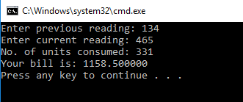

## Task 03:

#define _CRT_SECURE_NO_WARNINGS

#include <stdio.h>

#include <ctype.h>

int main()

{

char gender, first_name[23], last_name[20], married; // declaring variables

int age;

printf("What is your gender {M or F}: "); // asking for genders

scanf("%c", &gender);

printf("First Name: "); // asking for first and last name

scanf("%s", &first_name);

printf("Last Name: ");

scanf("%s", &last_name);

printf("Age: ");

scanf("%d", &age);

if (gender == 'f' || gender == 'F')

{

if (age >= 20)

{

printf("Are you married, %s (y or n)?", first_name); // asking for marriage

fflush(stdin); // clears the memory

scanf("%c", &married);

if (married == 'y' || married == 'Y')

{

printf("Then I shall call you Mrs. %s.\n", last_name); // calling Mrs. If married

}

else if (married == 'n' || married == 'N') // calling Ms. If not married

{

printf("Then I shall call you Ms. %s.\n", first_name);

}

}

else if (age < 20) // if less than 20 years then following occurs

{

printf("Then I shall call you %s %s.\n", first_name, last_name);

}

}

if (gender == 'm' || gender == 'M') // if male then following conditions apply

{

if (age > 20){

printf("Then I shall call you Mr. %s\n", first_name);

}

else if (age < 20){

printf("Then I shall call you %s %s\n", first_name, last_name);

}

}

return 0;

}

Output:

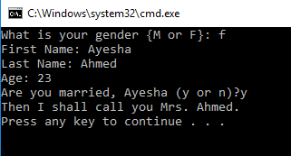

**Task 4:**

**Code:**

#define _CRT_SECURE_NO_WARNINGS

#include <stdio.h>.

int main()

{

int hours, lines_of_code;

double pay, gross_pay, net_pay, payroll_tax, bonus=0; // declaring variables

char first_name[10], last_name[10];

printf("***********************************\n");

printf("| CodePakistan Paycheck Generator |\n");

printf("***********************************\n");

printf("Enter the employee's first name: "); // asking for name, hours worked and lines of code

scanf("%s", &first_name);

printf("Enter the employee's last name: ");

scanf("%s", &last_name);

printf("Enter the hours worked: ");

scanf("%d", &hours);

printf("Enter the lines of code: ");

scanf("%d", &lines_of_code);

printf("\nPay Check for %s %s\n", first_name, last_name);

printf("---------------------------------\n");

if (hours <= 60 && hours > 40) {

pay = hours * 35;

printf("%d hours * Rs. 35 per hour = Rs. %.2f\n", hours, pay); // displaying pay if worked between 40 to 60 hours

}

else if (hours > 60 && hours<100) {

pay = hours * 45;

printf("%d hours * Rs. 45 per hour = Rs. %.2f\n", hours, pay); // displaying pay if worked for more than 60 hours and less than 100 hours

}

else if (hours <= 40) {

pay = hours * 30;

printf("%d hours * Rs. 30 per hour = Rs. %.2f\n", hours, pay); // displaying pay if worked less than 40 hours

}

if (lines_of_code > 1000) {

bonus += 1000; // giving bonus to the worker if he wrote more than 1000 lines of code

}

printf("Lines of code bonus=Rs. %.2f\n", bonus);

printf("---------------------------------\n");

gross_pay = pay + bonus; // calculating gross pay

printf("Gross Pay = Rs. %.2f\n", gross_pay);

printf("---------------------------------\n");

if (gross_pay >= 1900) {

payroll_tax = 0.11*gross_pay; // tax on gross pay if greater than 1900rs

}

else if (gross_pay < 1900) {

payroll_tax = 0.07*gross_pay; // tax on gross pay if lesser than 1900rs

}

printf("Payroll_tax = Rs. %.2f\n", payroll_tax);

printf("---------------------------------\n");

net_pay = gross_pay - payroll_tax;

printf("Net Pay = Rs. %.2f\n", net_pay);

}

**Output:**

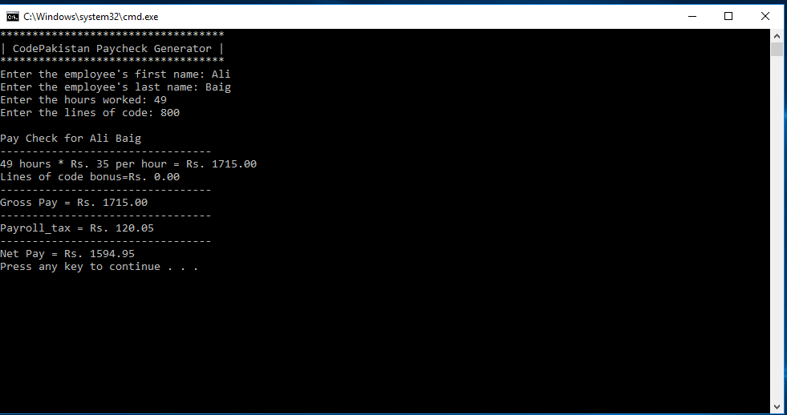

**TASK 05:**

#include <stdio.h>

#include <ctype.h>

int main()

{

    int x = 4, y;

    printf("TEH WORST NUBMER GESSING GAME EVAR!!!!!!!!!\n\n");

    printf("I\"M THKING OF A NBR FROM 1-10. TRY TO GESS!");

    scanf("%d", &y); // asking the user to guess the number

    if (y == x)

    {

        printf("\n\nLOL!!! U GOT IT! I CANT BELEIVE U GESSED IT WAS 4!\n"); // if user answers correct than displays the following message

    }

    else

    {

        printf("\n\nW00T! U SUX0R!!! I PWN J00!!! IT WAS 4!\n"); // id user answers wrong then displays the following message

    }

    return 0;

}

